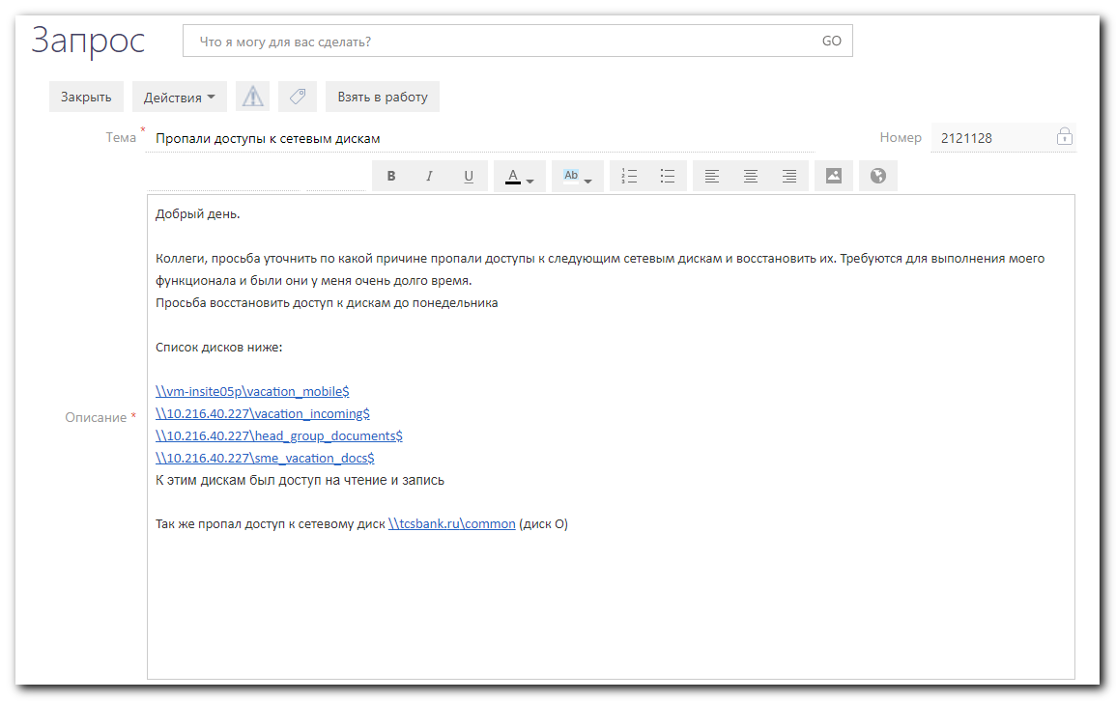

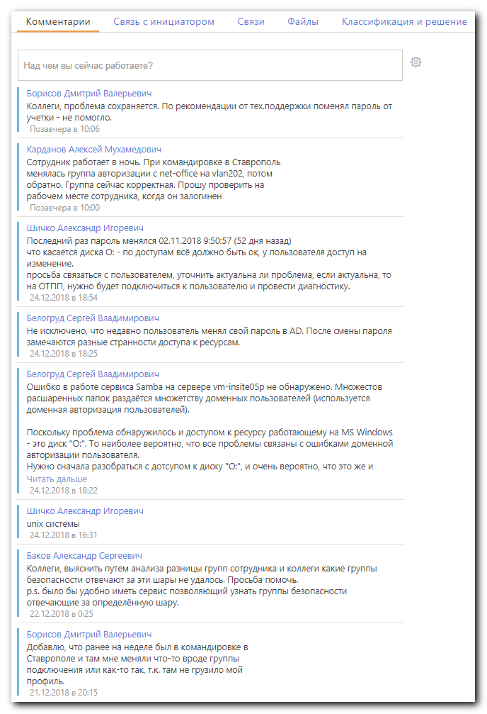
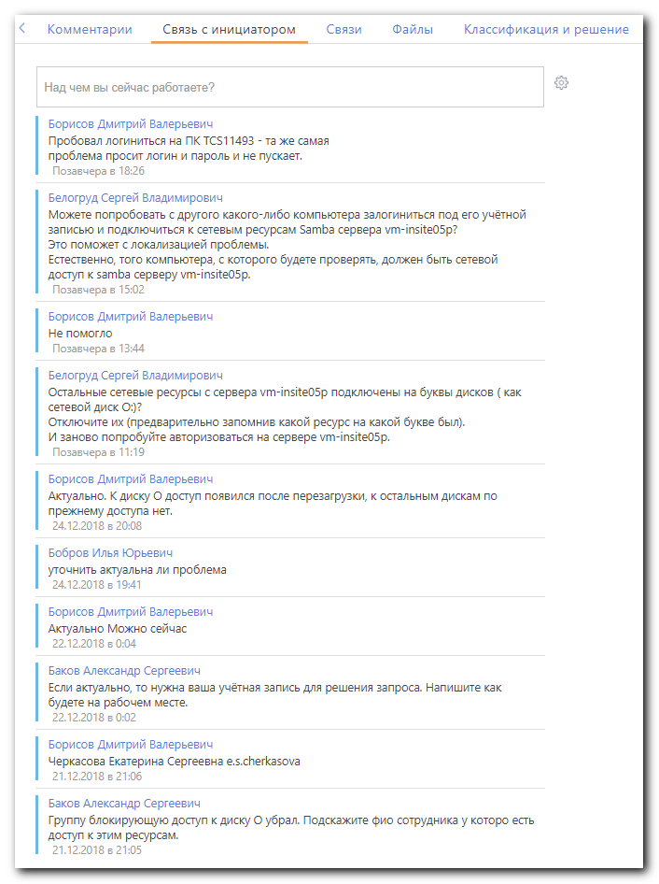

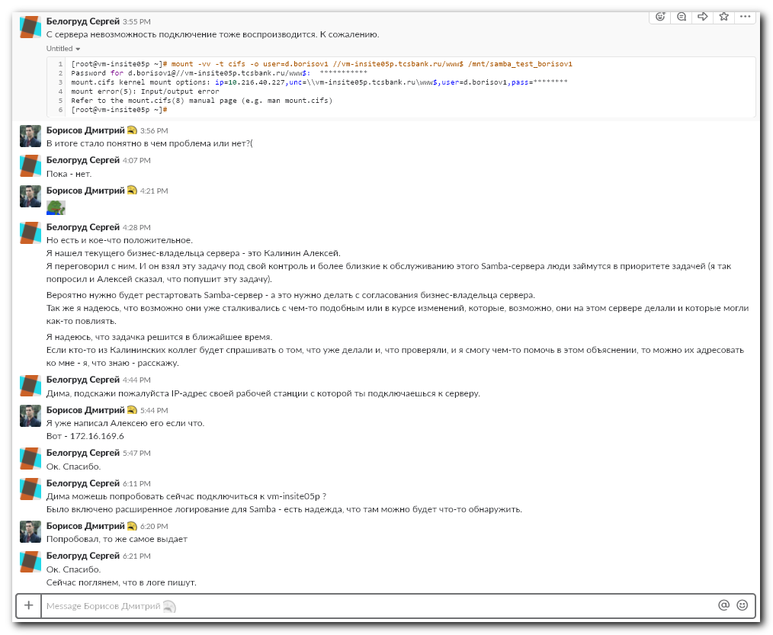
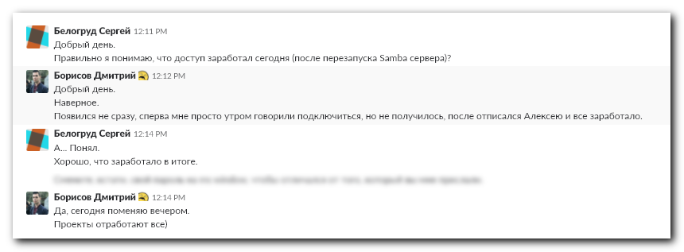

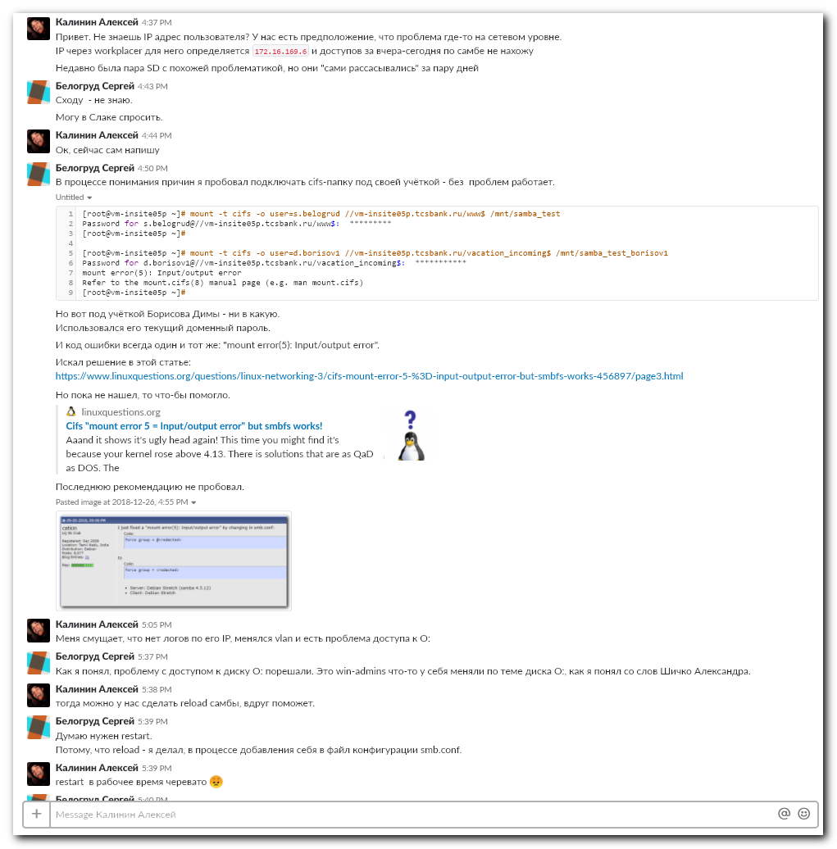
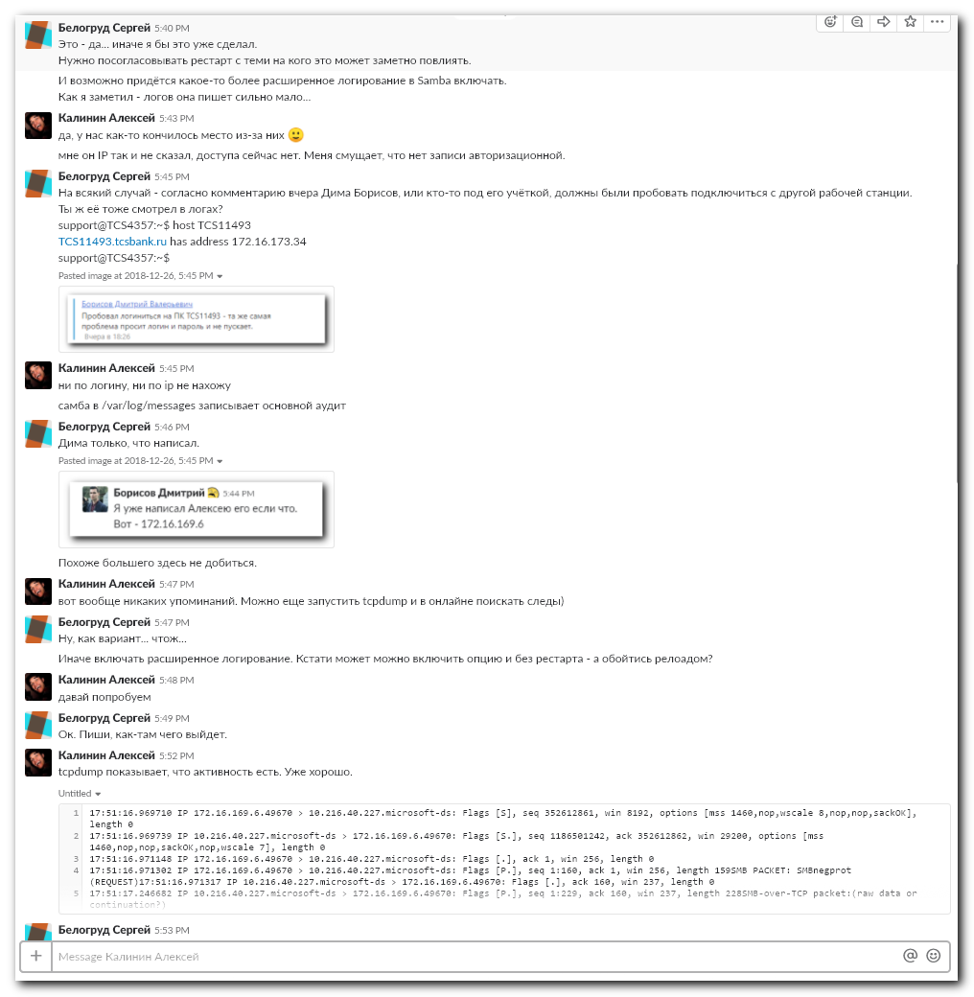
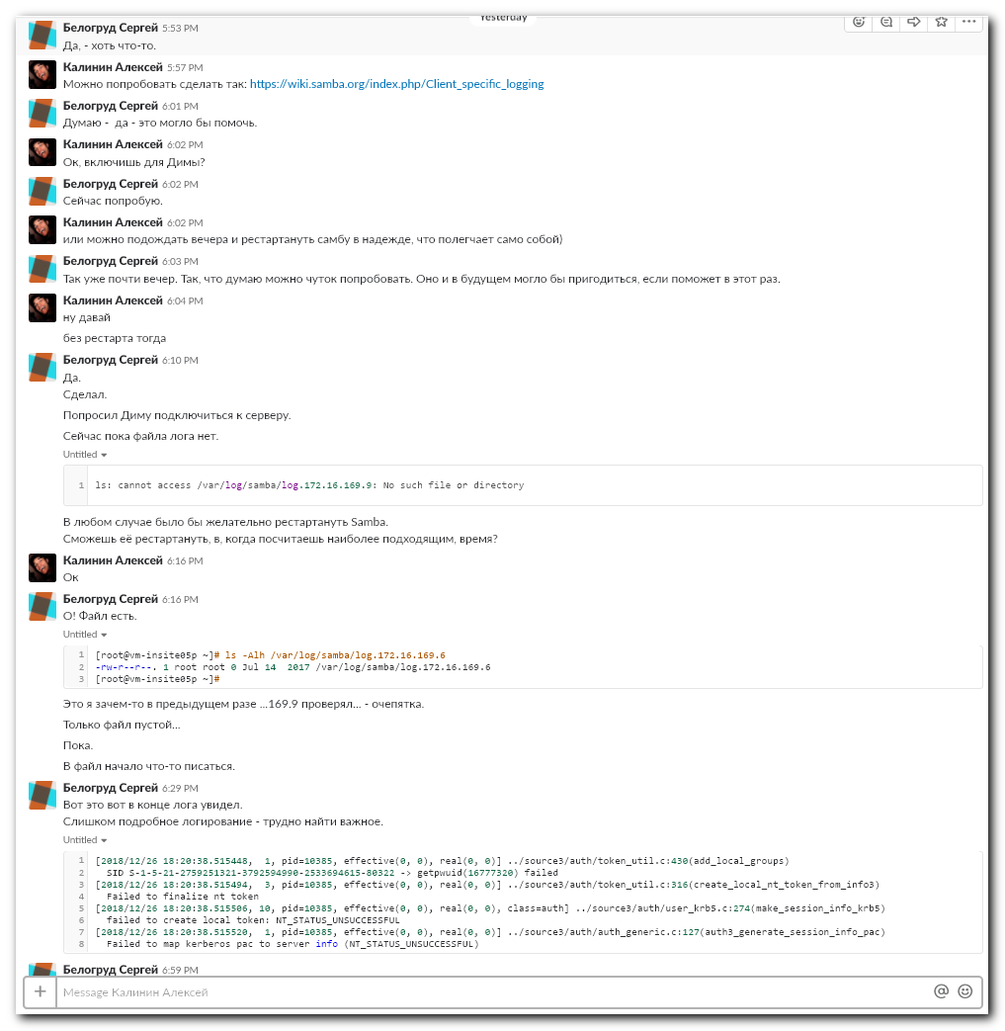
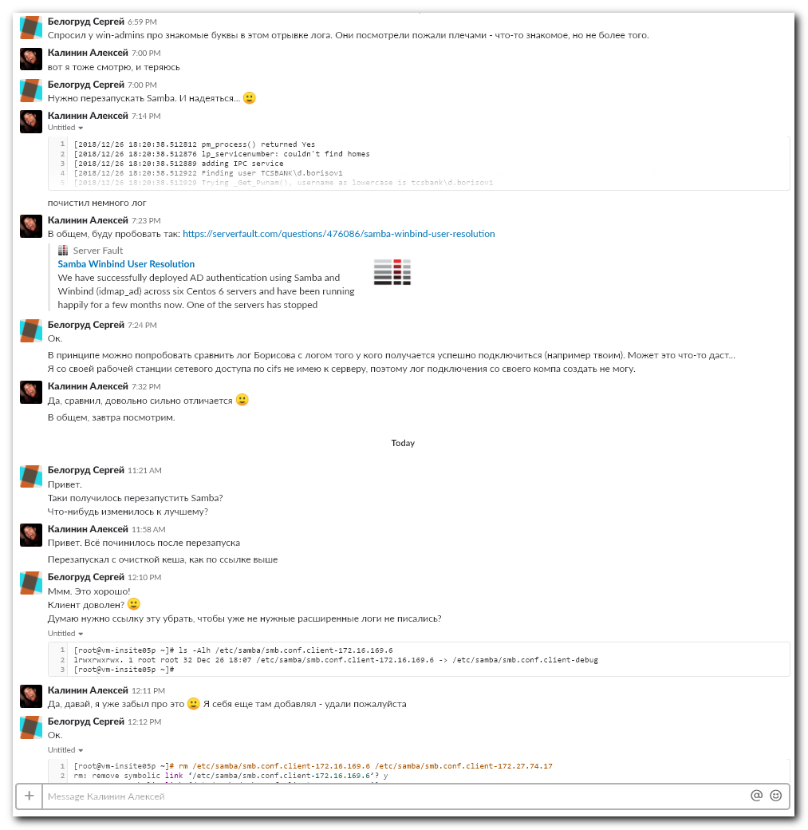
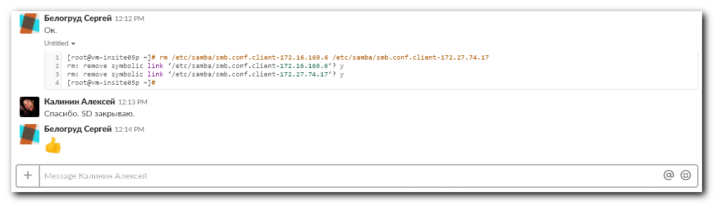

................................................................................

[root@vm-insite05p ~]# /usr/bin/testparm
Load smb config files from /etc/samba/smb.conf
Processing section "[www$]"
Processing section "[www5_root$]"
Processing section "[www5$]"
Processing section "[sale_insurance_procedures$]"
Processing section "[sale_insurance$]"
Processing section "[cc_know_documents$]"
Processing section "[collection$]"
Processing section "[departments$]"
Processing section "[displays$]"
Processing section "[dwh$]"
Processing section "[shop_employee_csv$]"
Processing section "[dwh_regions$]"
Processing section "[floor_plans$]"
Processing section "[hard_skills$]"
Processing section "[head_group_documents$]"
Processing section "[tm_head_group_documents$]"
Processing section "[issuing$]"
Processing section "[promo_students$]"
Processing section "[overtime_docs$]"
Processing section "[motivation$]"
Processing section "[quality$]"
Processing section "[sale_schedule_docs$]"
Processing section "[schedule$]"
Processing section "[schedule_oper$]"
Processing section "[vacation_mobile$]"
Processing section "[schedule_sale$]"
Processing section "[schedule_sec$]"
Processing section "[sec_documents$]"
Processing section "[sendings_report$]"
Processing section "[siebel$]"
Processing section "[sme_vacation_docs$]"
Processing section "[staff_templates$]"
Processing section "[templates$]"
Processing section "[bitrix_templates$]"
Processing section "[general$]"
Processing section "[general_monitors$]"
Processing section "[tm_mentoring_docs$]"
Processing section "[tm_vacation_docs$]"
Processing section "[training_department$]"
Processing section "[tstore_documents$]"
Processing section "[ukp_reports$]"
Processing section "[upload$]"
Processing section "[vacation_incoming$]"
Processing section "[vacation_sale$]"
Processing section "[verification_documents$]"
Processing section "[webim_log$]"
Processing section "[errors$]"
Processing section "[elearning$]"
Processing section "[representatives_list$]"
Processing section "[compliance_documents$]"
Processing section "[compliance_instructions$]"
Processing section "[pos_acq_delivery$]"
Processing section "[schedule_back_sme$]"
Processing section "[insurance_schedule$]"
Processing section "[tm_quality_docs$]"
Processing section "[tm_quality_leaders_docs$]"
Processing section "[tm_quality_general_docs$]"
Processing section "[dwh_pm$]"
Processing section "[nice-query-log$]"
Processing section "[sme_internal_rules_docs$]"
Processing section "[sme_sales_office_docs$]"
Processing section "[verification_instructions$]"
Processing section "[sme_chiefs_documents$]"
Loaded services file OK.
WARNING: The setting 'security=ads' should NOT be combined with the 'password server' parameter.
(by default Samba will discover the correct DC to contact automatically).

WARNING: You have some share names that are longer than 12 characters.
These may not be accessible to some older clients.
(Eg. Windows9x, WindowsMe, and smbclient prior to Samba 3.0.)
Server role: ROLE_DOMAIN_MEMBER

Press enter to see a dump of your service definitions

# Global parameters
[global]
realm = TCSBANK.RU
server string = Samba Server Version %v
workgroup = TCSBANK
log file = /var/log/samba/log.%m
max log size = 50
nt pipe support = No
password server = hq-msk-vol-dc02.tcsbank.ru
security = ADS
template shell = /bin/bash
winbind enum groups = Yes
winbind enum users = Yes
winbind expand groups = 10
winbind max clients = 2000
winbind refresh tickets = Yes
winbind rpc only = Yes
idmap config * : range = 16777216-33554431
idmap config * : backend = tdb
delete veto files = Yes
hide dot files = No
veto files = /*.pst/
cups options = raw

[www$]
path = /var/www/vm-insite04p.tcsbank.ru
blocking locks = No
kernel oplocks = Yes
create mask = 0775
directory mask = 0775
force group = apache
read only = No
valid users = @TCSBANK\cc_info_development TCSBANK\t.sultanov TCSBANK\i.komyagin @TCSBANK\a.sklyarov
vfs objects = full_audit
full_audit:priority = NOTICE
full_audit:facility = local5
full_audit:failure = mkdir pwrite rename rmdir unlink
full_audit:success = mkdir pwrite rename rmdir unlink

[www5_root$]
path = /var/www
create mask = 0775
directory mask = 0775
force group = apache
read only = No
valid users = @TCSBANK\cc_info_development @TCSBANK\a.sklyarov
vfs objects = full_audit
full_audit:priority = NOTICE
full_audit:facility = local5
full_audit:failure = mkdir pwrite rename rmdir unlink
full_audit:success = mkdir pwrite rename rmdir unlink

[www5$]
path = /var/www/insite
create mask = 0775
directory mask = 0775
force group = apache
read only = No
valid users = @TCSBANK\cc_info @TCSBANK\a.sklyarov
vfs objects = full_audit
full_audit:priority = NOTICE
full_audit:facility = local5
full_audit:failure = mkdir pwrite rename rmdir unlink
full_audit:success = mkdir pwrite rename rmdir unlink

[sale_insurance_procedures$]
path = /var/www/vm-insite04p.tcsbank.ru/departments/sale_insurance/procedures
create mask = 0775
directory mask = 0775
force group = apache
read only = No
valid users = @TCSBANK\cc_info @TCSBANK\sales_ins_communications @TCSBANK\a.sklyarov
vfs objects = full_audit
full_audit:priority = NOTICE
full_audit:facility = local5
full_audit:failure = mkdir pwrite rename rmdir unlink
full_audit:success = mkdir pwrite rename rmdir unlink

[sale_insurance$]
path = /var/www/vm-insite04p.tcsbank.ru/departments/sale_insurance
create mask = 0775
directory mask = 0775
force group = apache
read only = No
valid users = @TCSBANK\cc_info @TCSBANK\sales_ins_communications @TCSBANK\a.sklyarov
vfs objects = full_audit
full_audit:priority = NOTICE
full_audit:facility = local5
full_audit:failure = mkdir pwrite rename rmdir unlink
full_audit:success = mkdir pwrite rename rmdir unlink

[cc_know_documents$]
path = /var/www/vm-insite04p.tcsbank.ru/departments/corporate_university/training_department/statements/documents
create mask = 0775
directory mask = 0775
force group = apache
read only = No
valid users = @TCSBANK\cc_info @TCSBANK\cc_know @TCSBANK\a.sklyarov
vfs objects = full_audit
full_audit:priority = NOTICE
full_audit:facility = local5
full_audit:failure = mkdir pwrite rename rmdir unlink
full_audit:success = mkdir pwrite rename rmdir unlink

[collection$]
path = /var/www/vm-insite04p.tcsbank.ru/departments/collection/interactive
create mask = 0777
directory mask = 0777
force group = apache
read only = No
valid users = @TCSBANK\cc_info @TCSBANK\tasks_user @TCSBANK\insite_collection_editors @TCSBANK\a.sklyarov
vfs objects = full_audit
full_audit:priority = NOTICE
full_audit:facility = local5
full_audit:failure = mkdir pwrite rename rmdir unlink
full_audit:success = mkdir pwrite rename rmdir unlink

[departments$]
path = /var/www/vm-insite04p.tcsbank.ru/departments
create mask = 0775
directory mask = 0775
force group = apache
read only = No
valid users = @TCSBANK\cc_info @TCSBANK\cc_info_help @TCSBANK\a.sklyarov @TCSBANK\n.lopatkin
vfs objects = full_audit
full_audit:priority = NOTICE
full_audit:facility = local5
full_audit:failure = mkdir pwrite rename rmdir unlink
full_audit:success = mkdir pwrite rename rmdir unlink

[displays$]
path = /var/www/vm-insite04p.tcsbank.ru/displays
create mask = 0775
directory mask = 0775
force group = apache
guest ok = Yes
write list = @TCSBANK\cc_info TCSBANK\l.gogoladze TCSBANK\y.kapustin TCSBANK\scalauser @TCSBANK\a.sklyarov

[dwh$]
path = /var/www/vm-insite04p.tcsbank.ru/upload/dwh
create mask = 0775
directory mask = 0775
force group = apache
read only = No
valid users = @TCSBANK\cc_info @TCSBANK\cc_oper TCSBANK\scalauser TCSBANK\k.kovrigin TCSBANK\insite TCSBANK\v.karpeev TCSBANK\a.lopatnikov @TCSBANK\a.sklyarov
vfs objects = full_audit
full_audit:priority = NOTICE
full_audit:facility = local5
full_audit:failure = mkdir pwrite rename rmdir unlink
full_audit:success = mkdir pwrite rename rmdir unlink

[shop_employee_csv$]
path = /var/www/vm-insite04p.tcsbank.ru/upload/dwh/personal_cabinet/shop
create mask = 0775
directory mask = 0775
force group = apache
read only = No
valid users = @TCSBANK\cc_info TCSBANK\v.agavelov TCSBANK\d.o.yakovlev @TCSBANK\verif_processing @TCSBANK\a.sklyarov
vfs objects = full_audit
full_audit:priority = NOTICE
full_audit:facility = local5
full_audit:failure = mkdir pwrite rename rmdir unlink
full_audit:success = mkdir pwrite rename rmdir unlink

[dwh_regions$]
path = /var/www/vm-insite04p.tcsbank.ru/upload/dwh/regions
create mask = 0775
directory mask = 0775
force group = apache
read only = No
valid users = @TCSBANK\cc_info @TCSBANK\osp_tech @TCSBANK\osp_raspred @TCSBANK\a.sklyarov
vfs objects = full_audit
full_audit:priority = NOTICE
full_audit:facility = local5
full_audit:failure = mkdir pwrite rename rmdir unlink
full_audit:success = mkdir pwrite rename rmdir unlink

[floor_plans$]
path = /var/www/vm-insite04p.tcsbank.ru/upload/floor_plans
create mask = 0775
directory mask = 0775
force group = apache
read only = No
valid users = @TCSBANK\cc_info @TCSBANK\Sec_infobez @TCSBANK\helpdesk_it @TCSBANK\Ins_process @TCSBANK\know_revision @TCSBANK\cc_processes @TCSBANK\OTP_ALL TI\a.shchepkov TCSBANK\d.kolosov TCSBANK\i.ilyenko TCSBANK\a.a.gerasimov TCSBANK\m.protasova TCSBANK\websoft @TCSBANK\telsqlcluster_aicsqlserver_accesss TCSBANK\i.komyagin TCSBANK\a.mangashev @TCSBANK\remote_support @TCSBANK\a.sklyarov
vfs objects = full_audit
full_audit:priority = NOTICE
full_audit:facility = local5
full_audit:failure = mkdir pwrite rename rmdir unlink
full_audit:success = mkdir pwrite rename rmdir unlink

[hard_skills$]
path = /var/www/vm-insite04p.tcsbank.ru/departments/corporate_university/hard_skills
create mask = 0775
directory mask = 0775
force group = apache
read only = No
valid users = @TCSBANK\cc_info @TCSBANK\Know_revision_send_as @TCSBANK\cc_know @TCSBANK\a.sklyarov
vfs objects = full_audit
full_audit:priority = NOTICE
full_audit:facility = local5
full_audit:failure = mkdir pwrite rename rmdir unlink
full_audit:success = mkdir pwrite rename rmdir unlink

[head_group_documents$]
path = /var/www/vm-insite04p.tcsbank.ru/departments/incoming/staff/head_group/documents
create mask = 0775
directory mask = 0775
force group = apache
read only = No
valid users = @TCSBANK\cc_info @TCSBANK\cc_sector @TCSBANK\quality_revision @TCSBANK\insite_oper_editors @TCSBANK\quality_advance @TCSBANK\cc_processes @TCSBANK\cc_quality @TCSBANK\resource_optimization TCSBANK\i.izyumov TCSBANK\a.bomko @TCSBANK\a.sklyarov
vfs objects = full_audit
full_audit:priority = NOTICE
full_audit:facility = local5
full_audit:failure = mkdir pwrite rename rmdir unlink
full_audit:success = mkdir pwrite rename rmdir unlink

[tm_head_group_documents$]
path = /var/www/vm-insite04p.tcsbank.ru/departments/telemarketing/staff/head_group/documents
create mask = 0775
directory mask = 0775
force group = apache
read only = No
valid users = @TCSBANK\cc_info @TCSBANK\cc_sector @TCSBANK\quality_revision @TCSBANK\insite_oper_editors @TCSBANK\quality_advance @TCSBANK\cc_processes @TCSBANK\cc_quality @TCSBANK\resource_optimization @TCSBANK\a.sklyarov
vfs objects = full_audit
full_audit:priority = NOTICE
full_audit:facility = local5
full_audit:failure = mkdir pwrite rename rmdir unlink
full_audit:success = mkdir pwrite rename rmdir unlink

[issuing$]
path = /var/www/vm-insite04p.tcsbank.ru/departments/quality/regulations/issuing
create mask = 0775
directory mask = 0775
force group = apache
guest ok = Yes
read only = No
valid users = @TCSBANK\cc_info TCSBANK\n.elenskaya TCSBANK\m.lashkov @TCSBANK\cc_processes TCSBANK\e.otroshchenko @TCSBANK\osp_tech TCSBANK\a.kovaleva4 @TCSBANK\a.sklyarov
vfs objects = full_audit
full_audit:priority = NOTICE
full_audit:facility = local5
full_audit:failure = mkdir pwrite rename rmdir unlink
full_audit:success = mkdir pwrite rename rmdir unlink

[promo_students$]
path = /var/www/vm-insite04p.tcsbank.ru/departments/incoming/actions/students
create mask = 0775
directory mask = 0775
force group = apache
guest ok = Yes
read only = No
valid users = @TCSBANK\cc_info @TCSBANK\analytics @TCSBANK\cc_processes @TCSBANK\a.sklyarov
vfs objects = full_audit
full_audit:priority = NOTICE
full_audit:facility = local5
full_audit:failure = mkdir pwrite rename rmdir unlink
full_audit:success = mkdir pwrite rename rmdir unlink

[overtime_docs$]
path = /var/www/vm-insite04p.tcsbank.ru/departments/incoming/staff/overtime/docs
create mask = 0775
directory mask = 0775
force group = apache
read only = No
valid users = @TCSBANK\cc_info @TCSBANK\resource_optimization @TCSBANK\a.sklyarov
vfs objects = full_audit
full_audit:priority = NOTICE
full_audit:facility = local5
full_audit:failure = mkdir pwrite rename rmdir unlink
full_audit:success = mkdir pwrite rename rmdir unlink

[motivation$]
path = /var/www/vm-insite04p.tcsbank.ru/departments/incoming/staff/motivation
create mask = 0775
directory mask = 0775
force group = apache
read only = No
valid users = @TCSBANK\cc_info @TCSBANK\cc_head_of_sector @TCSBANK\cc_info_development @TCSBANK\a.sklyarov
vfs objects = full_audit
full_audit:priority = NOTICE
full_audit:facility = local5
full_audit:failure = mkdir pwrite rename rmdir unlink
full_audit:success = mkdir pwrite rename rmdir unlink

[quality$]
path = /var/www/vm-insite04p.tcsbank.ru/upload/quality
create mask = 0775
directory mask = 0775
force group = apache
read only = No
valid users = @TCSBANK\cc_info @TCSBANK\cc_quality TCSBANK\v.parfenov @TCSBANK\a.sklyarov
vfs objects = full_audit
full_audit:priority = NOTICE
full_audit:facility = local5
full_audit:failure = mkdir pwrite rename rmdir unlink
full_audit:success = mkdir pwrite rename rmdir unlink

[sale_schedule_docs$]
path = /var/www/vm-insite04p.tcsbank.ru/departments/sale/staff/schedule/docs
create mask = 0775
directory mask = 0775
force group = apache
read only = No
valid users = @TCSBANK\cc_info @TCSBANK\head_mortgage @TCSBANK\team_mortgage @TCSBANK\a.sklyarov
vfs objects = full_audit
full_audit:priority = NOTICE
full_audit:facility = local5
full_audit:failure = mkdir pwrite rename rmdir unlink
full_audit:success = mkdir pwrite rename rmdir unlink

[schedule$]
path = /var/www/vm-insite04p.tcsbank.ru/departments/incoming/staff/schedule
create mask = 0777
directory mask = 0777
force group = apache
read only = No
valid users = @TCSBANK\cc_info @TCSBANK\insite_oper_editors TCSBANK\v.karpeev @TCSBANK\cc_oper @TCSBANK\quality_revision @TCSBANK\resource_optimization @TCSBANK\tm_monitoring @TCSBANK\a.sklyarov
vfs objects = full_audit
full_audit:priority = NOTICE
full_audit:facility = local5
full_audit:failure = mkdir pwrite rename rmdir unlink
full_audit:success = mkdir pwrite rename rmdir unlink

[schedule_oper$]
path = /var/www/vm-insite04p.tcsbank.ru/departments/operational_planning/schedule
create mask = 0775
directory mask = 0775
force group = apache
read only = No
valid users = @TCSBANK\cc_info @TCSBANK\insite_oper_editors TCSBANK\d.orobets @TCSBANK\a.sklyarov
vfs objects = full_audit
full_audit:priority = NOTICE
full_audit:facility = local5
full_audit:failure = mkdir pwrite rename rmdir unlink
full_audit:success = mkdir pwrite rename rmdir unlink

[vacation_mobile$]
path = /var/www/vm-insite04p.tcsbank.ru/departments/mobile/staff/vacation
create mask = 0775
directory mask = 0775
force group = apache
read only = No
valid users = @TCSBANK\cc_info @TCSBANK\insite_oper_editors @TCSBANK\a.sklyarov
vfs objects = full_audit
full_audit:priority = NOTICE
full_audit:facility = local5
full_audit:failure = mkdir pwrite rename rmdir unlink
full_audit:success = mkdir pwrite rename rmdir unlink

[schedule_sale$]
path = /var/www/vm-insite04p.tcsbank.ru/departments/sale/staff/schedule
create mask = 0775
directory mask = 0775
force group = apache
read only = No
valid users = @TCSBANK\cc_info TCSBANK\g.chebanu TCSBANK\a.nalimova TCSBANK\n.e.kachurina TCSBANK\i.makueva TCSBANK\t.i.stal @TCSBANK\insite_oper_editors TCSBANK\a.pichugin TCSBANK\y.yatskevich TCSBANK\y.boriskina @TCSBANK\cc_oper TCSBANK\o.gorbunova @TCSBANK\a.sklyarov
vfs objects = full_audit
full_audit:priority = NOTICE
full_audit:facility = local5
full_audit:failure = mkdir pwrite rename rmdir unlink
full_audit:success = mkdir pwrite rename rmdir unlink

[schedule_sec$]
path = /var/www/vm-insite04p.tcsbank.ru/departments/incoming/staff/sec/schedule
create mask = 0775
directory mask = 0775
force group = apache
read only = No
valid users = @TCSBANK\cc_info @TCSBANK\quality_revision @TCSBANK\cc_mail_head @TCSBANK\sec_chiefs @TCSBANK\a.sklyarov
vfs objects = full_audit
full_audit:priority = NOTICE
full_audit:facility = local5
full_audit:failure = mkdir pwrite rename rmdir unlink
full_audit:success = mkdir pwrite rename rmdir unlink

[sec_documents$]
path = /var/www/vm-insite04p.tcsbank.ru/departments/incoming/staff/sec/documents
create mask = 0775
directory mask = 0775
force group = apache
read only = No
valid users = @TCSBANK\cc_info @TCSBANK\insite_oper_editors @TCSBANK\sec_chiefs @TCSBANK\oeo_resources TCSBANK\s.nikitin @TCSBANK\quality_heads @TCSBANK\a.sklyarov
vfs objects = full_audit
full_audit:priority = NOTICE
full_audit:facility = local5
full_audit:failure = mkdir pwrite rename rmdir unlink
full_audit:success = mkdir pwrite rename rmdir unlink

[sendings_report$]
path = /var/www/vm-insite04p.tcsbank.ru/departments/telemarketing/manual/sendings/sendings_report
create mask = 0775
directory mask = 0775
force group = apache
read only = No
valid users = @TCSBANK\cc_info @TCSBANK\osp_reg_managers @TCSBANK\osp_tutors @TCSBANK\osp_raspred @TCSBANK\insite_sale_support_editors @TCSBANK\a.sklyarov
vfs objects = full_audit
full_audit:priority = NOTICE
full_audit:facility = local5
full_audit:failure = mkdir pwrite rename rmdir unlink
full_audit:success = mkdir pwrite rename rmdir unlink

[siebel$]
path = /var/www/vm-insite04p.tcsbank.ru/departments/incoming/systems/siebel
create mask = 0775
directory mask = 0775
force group = apache
read only = No
valid users = @TCSBANK\cc_info @TCSBANK\cc_processes @TCSBANK\a.sklyarov
vfs objects = full_audit
full_audit:priority = NOTICE
full_audit:facility = local5
full_audit:failure = mkdir pwrite rename rmdir unlink
full_audit:success = mkdir pwrite rename rmdir unlink

[sme_vacation_docs$]
path = /var/www/vm-insite04p.tcsbank.ru/departments/tinkoff_business/staff/vacation/docs
create mask = 0775
directory mask = 0775
force group = apache
read only = No
valid users = @TCSBANK\cc_info @TCSBANK\cc_oper @TCSBANK\a.sklyarov
vfs objects = full_audit
full_audit:priority = NOTICE
full_audit:facility = local5
full_audit:failure = mkdir pwrite rename rmdir unlink
full_audit:success = mkdir pwrite rename rmdir unlink

[staff_templates$]
path = /var/www/vm-insite04p.tcsbank.ru/departments/incoming/staff/schedule/templates
create mask = 0775
directory mask = 0775
force group = apache
read only = No
valid users = @TCSBANK\cc_info @TCSBANK\resource_optimization @TCSBANK\a.sklyarov
vfs objects = full_audit
full_audit:priority = NOTICE
full_audit:facility = local5
full_audit:failure = mkdir pwrite rename rmdir unlink
full_audit:success = mkdir pwrite rename rmdir unlink

[templates$]
path = /var/www/vm-insite04p.tcsbank.ru/GENERAL/templates
create mask = 0775
directory mask = 0775
force group = apache
read only = No
valid users = @TCSBANK\cc_info @TCSBANK\cc_info_help @TCSBANK\a.sklyarov
vfs objects = full_audit
full_audit:priority = NOTICE
full_audit:facility = local5
full_audit:failure = mkdir pwrite rename rmdir unlink
full_audit:success = mkdir pwrite rename rmdir unlink

[bitrix_templates$]
path = /var/www/vm-insite04p.tcsbank.ru/bitrix/templates
create mask = 0775
directory mask = 0775
force group = apache
read only = No
valid users = @TCSBANK\cc_info @TCSBANK\a.sklyarov
vfs objects = full_audit
full_audit:priority = NOTICE
full_audit:facility = local5
full_audit:failure = mkdir pwrite rename rmdir unlink
full_audit:success = mkdir pwrite rename rmdir unlink

[general$]
path = /var/www/vm-insite04p.tcsbank.ru/GENERAL
create mask = 0775
directory mask = 0775
force group = apache
read only = No
valid users = @TCSBANK\cc_info @TCSBANK\a.sklyarov
vfs objects = full_audit
full_audit:priority = NOTICE
full_audit:facility = local5
full_audit:failure = mkdir pwrite rename rmdir unlink
full_audit:success = mkdir pwrite rename rmdir unlink

[general_monitors$]
path = /var/www/vm-insite04p.tcsbank.ru/GENERAL/monitors
create mask = 0775
directory mask = 0775
force group = apache
read only = No
valid users = @TCSBANK\cc_info_development TCSBANK\a.bogachev @TCSBANK\a.sklyarov
vfs objects = full_audit
full_audit:priority = NOTICE
full_audit:facility = local5
full_audit:failure = mkdir pwrite rename rmdir unlink
full_audit:success = mkdir pwrite rename rmdir unlink

[tm_mentoring_docs$]
path = /var/www/vm-insite04p.tcsbank.ru/departments/telemarketing/staff/mentoring/docs
create mask = 0775
directory mask = 0775
force group = apache
read only = No
valid users = @TCSBANK\cc_info @TCSBANK\know_adaptation @TCSBANK\a.sklyarov
vfs objects = full_audit
full_audit:priority = NOTICE
full_audit:facility = local5
full_audit:failure = mkdir pwrite rename rmdir unlink
full_audit:success = mkdir pwrite rename rmdir unlink

[tm_vacation_docs$]
path = /var/www/vm-insite04p.tcsbank.ru/departments/telemarketing/staff/vacation/docs
create mask = 0775
directory mask = 0775
force group = apache
read only = No
valid users = @TCSBANK\cc_info @TCSBANK\tm_chief @TCSBANK\a.sklyarov
vfs objects = full_audit
full_audit:priority = NOTICE
full_audit:facility = local5
full_audit:failure = mkdir pwrite rename rmdir unlink
full_audit:success = mkdir pwrite rename rmdir unlink

[training_department$]
path = /var/www/vm-insite04p.tcsbank.ru/departments/corporate_university/training_department
create mask = 0775
directory mask = 0775
force group = apache
read only = No
valid users = @TCSBANK\cc_info @TCSBANK\know_revision TCSBANK\d.dzheylani TCSBANK\k.osnovenko @TCSBANK\Know_revision_send_as @TCSBANK\cc_know TCSBANK\e.tinkov TCSBANK\a.rezvinskaya @TCSBANK\a.sklyarov
vfs objects = full_audit
full_audit:priority = NOTICE
full_audit:facility = local5
full_audit:failure = mkdir pwrite rename rmdir unlink
full_audit:success = mkdir pwrite rename rmdir unlink

[tstore_documents$]
path = /var/www/vm-insite04p.tcsbank.ru/departments/sale/staff/tstore/documents
create mask = 0775
directory mask = 0775
force group = apache
read only = No
valid users = @TCSBANK\cc_info TCSBANK\i.makueva TCSBANK\y.boriskina TCSBANK\o.gorbunova @TCSBANK\a.sklyarov
vfs objects = full_audit
full_audit:priority = NOTICE
full_audit:facility = local5
full_audit:failure = mkdir pwrite rename rmdir unlink
full_audit:success = mkdir pwrite rename rmdir unlink

[ukp_reports$]
path = /var/www/vm-insite04p.tcsbank.ru/departments/incoming/staff/ukp/documents
create mask = 0775
directory mask = 0775
force group = apache
read only = No
valid users = @TCSBANK\cc_info TCSBANK\d.volgin TCSBANK\d.rusanov TCSBANK\a.a.kuzmin @TCSBANK\cc_head_of_group @TCSBANK\cc_head_of_sector @TCSBANK\cc_processes TCSBANK\t.timoshin @TCSBANK\a.sklyarov
vfs objects = full_audit
full_audit:priority = NOTICE
full_audit:facility = local5
full_audit:failure = mkdir pwrite rename rmdir unlink
full_audit:success = mkdir pwrite rename rmdir unlink

[upload$]
path = /var/www/vm-insite04p.tcsbank.ru/upload
create mask = 0775
directory mask = 0775
force group = apache
read only = No
valid users = @TCSBANK\cc_info @TCSBANK\cc_info_help @TCSBANK\a.sklyarov
vfs objects = full_audit
full_audit:priority = NOTICE
full_audit:facility = local5
full_audit:failure = mkdir pwrite rename rmdir unlink
full_audit:success = mkdir pwrite rename rmdir unlink

[vacation_incoming$]
path = /var/www/vm-insite04p.tcsbank.ru/departments/incoming/staff/vacation
create mask = 0775
directory mask = 0775
force group = apache
read only = No
valid users = @TCSBANK\cc_info @TCSBANK\insite_oper_editors TCSBANK\d.borisov1 @TCSBANK\a.sklyarov
vfs objects = full_audit
full_audit:priority = NOTICE
full_audit:facility = local5
full_audit:failure = mkdir pwrite rename rmdir unlink
full_audit:success = mkdir pwrite rename rmdir unlink

[vacation_sale$]
path = /var/www/vm-insite04p.tcsbank.ru/departments/sale/staff/vacation/documents
create mask = 0775
directory mask = 0775
force group = apache
read only = No
valid users = @TCSBANK\cc_info @TCSBANK\insite_oper_editors @TCSBANK\sales_schedule @TCSBANK\a.sklyarov
vfs objects = full_audit
full_audit:priority = NOTICE
full_audit:facility = local5
full_audit:failure = mkdir pwrite rename rmdir unlink
full_audit:success = mkdir pwrite rename rmdir unlink

[verification_documents$]
path = /var/www/vm-insite04p.tcsbank.ru/departments/verification/documents
create mask = 0775
directory mask = 0775
force group = apache
read only = No
valid users = @TCSBANK\cc_info @TCSBANK\insite_verification_editors TCSBANK\vp_user1 @TCSBANK\verif_processing @TCSBANK\a.sklyarov
vfs objects = full_audit
full_audit:priority = NOTICE
full_audit:facility = local5
full_audit:failure = mkdir pwrite rename rmdir unlink
full_audit:success = mkdir pwrite rename rmdir unlink

[webim_log$]
path = /var/www/vm-insite04p.tcsbank.ru/departments/operational_planning/statistics/webim/log
create mask = 0775
directory mask = 0775
force group = apache
read only = No
valid users = @TCSBANK\cc_info @TCSBANK\cc_oper @TCSBANK\a.sklyarov
vfs objects = full_audit
full_audit:priority = NOTICE
full_audit:facility = local5
full_audit:failure = mkdir pwrite rename rmdir unlink
full_audit:success = mkdir pwrite rename rmdir unlink

[errors$]
path = /var/log/php
create mask = 0775
directory mask = 0775
force group = apache
read only = No
valid users = @TCSBANK\cc_info @TCSBANK\methodology_collection @TCSBANK\a.sklyarov
vfs objects = full_audit
full_audit:priority = NOTICE
full_audit:facility = local5
full_audit:failure = mkdir pwrite rename rmdir unlink
full_audit:success = mkdir pwrite rename rmdir unlink

[elearning$]
path = /var/www/vm-insite04p.tcsbank.ru/departments/corporate_university/elearning
create mask = 0775
directory mask = 0775
force group = apache
read only = No
valid users = @TCSBANK\cc_info @TCSBANK\courses @TCSBANK\a.sklyarov
vfs objects = full_audit
full_audit:priority = NOTICE
full_audit:facility = local5
full_audit:failure = mkdir pwrite rename rmdir unlink
full_audit:success = mkdir pwrite rename rmdir unlink

[representatives_list$]
path = /var/www/vm-insite04p.tcsbank.ru/departments/incoming/manual/representatives_list/files
create mask = 0775
directory mask = 0775
force group = apache
read only = No
valid users = @TCSBANK\cc_info @TCSBANK\osp_tech @TCSBANK\a.sklyarov
vfs objects = full_audit
full_audit:priority = NOTICE
full_audit:facility = local5
full_audit:failure = mkdir pwrite rename rmdir unlink
full_audit:success = mkdir pwrite rename rmdir unlink

[compliance_documents$]
path = /var/www/vm-insite04p.tcsbank.ru/departments/compliance/documents
create mask = 0775
directory mask = 0775
force group = apache
read only = No
valid users = @TCSBANK\cc_info @TCSBANK\sme_compliance_processing TCSBANK\a.orazbaev @TCSBANK\a.sklyarov
vfs objects = full_audit
full_audit:priority = NOTICE
full_audit:facility = local5
full_audit:failure = mkdir pwrite rename rmdir unlink
full_audit:success = mkdir pwrite rename rmdir unlink

[compliance_instructions$]
path = "/var/www/vm-insite04p.tcsbank.ru/departments/compliance/documents/sme compliance instructions"
create mask = 0775
directory mask = 0775
force group = apache
read only = No
valid users = @TCSBANK\cc_info @TCSBANK\sme_compliance_processing @TCSBANK\sme_compliance_audit @TCSBANK\a.sklyarov
vfs objects = full_audit
full_audit:priority = NOTICE
full_audit:facility = local5
full_audit:failure = mkdir pwrite rename rmdir unlink
full_audit:success = mkdir pwrite rename rmdir unlink

[pos_acq_delivery$]
path = /var/www/vm-insite04p.tcsbank.ru/departments/tinkoff_business/manual/sendings/pos_acq_delivery
create mask = 0775
directory mask = 0775
force group = apache
read only = No
valid users = @TCSBANK\cc_info @TCSBANK\sklad @TCSBANK\a.sklyarov
vfs objects = full_audit
full_audit:priority = NOTICE
full_audit:facility = local5
full_audit:failure = mkdir pwrite rename rmdir unlink
full_audit:success = mkdir pwrite rename rmdir unlink

[schedule_back_sme$]
path = /var/www/vm-insite04p.tcsbank.ru/departments/backoffice_business/staff/schedule/docs
create mask = 0775
directory mask = 0775
force group = apache
read only = No
valid users = @TCSBANK\cc_info @TCSBANK\sme_back_sector @TCSBANK\a.sklyarov
vfs objects = full_audit
full_audit:priority = NOTICE
full_audit:facility = local5
full_audit:failure = mkdir pwrite rename rmdir unlink
full_audit:success = mkdir pwrite rename rmdir unlink

[insurance_schedule$]
path = /var/www/vm-insite04p.tcsbank.ru/departments/insurance_incoming/staff/schedule/docs
create mask = 0775
directory mask = 0775
force group = apache
read only = No
valid users = @TCSBANK\cc_info TCSBANK\d.belomutskiy TCSBANK\r.shakirov1 @TCSBANK\a.sklyarov
vfs objects = full_audit
full_audit:priority = NOTICE
full_audit:facility = local5
full_audit:failure = mkdir pwrite rename rmdir unlink
full_audit:success = mkdir pwrite rename rmdir unlink

[tm_quality_docs$]
path = /var/www/vm-insite04p.tcsbank.ru/departments/telemarketing/staff/regulations/documents/files
create mask = 0775
directory mask = 0775
force group = apache
read only = No
valid users = @TCSBANK\cc_info TCSBANK\s.shakina TCSBANK\y.matveeva TCSBANK\e.v.ivanova TCSBANK\d.g.vasyukov TCSBANK\e.a.novikova @TCSBANK\a.sklyarov
vfs objects = full_audit
full_audit:priority = NOTICE
full_audit:facility = local5
full_audit:failure = mkdir pwrite rename rmdir unlink
full_audit:success = mkdir pwrite rename rmdir unlink

[tm_quality_leaders_docs$]
path = /var/www/vm-insite04p.tcsbank.ru/departments/telemarketing/templates/leaders/files
create mask = 0775
directory mask = 0775
force group = apache
read only = No
valid users = @TCSBANK\cc_info TCSBANK\s.shakina TCSBANK\y.matveeva TCSBANK\e.v.ivanova TCSBANK\d.g.vasyukov TCSBANK\e.a.novikova TCSBANK\r.selikhov @TCSBANK\a.sklyarov
vfs objects = full_audit
full_audit:priority = NOTICE
full_audit:facility = local5
full_audit:failure = mkdir pwrite rename rmdir unlink
full_audit:success = mkdir pwrite rename rmdir unlink

[tm_quality_general_docs$]
path = /var/www/vm-insite04p.tcsbank.ru/departments/telemarketing/templates/general/files
create mask = 0775
directory mask = 0775
force group = apache
read only = No
valid users = @TCSBANK\cc_info TCSBANK\s.shakina TCSBANK\y.matveeva TCSBANK\e.v.ivanova TCSBANK\d.g.vasyukov TCSBANK\e.a.novikova @TCSBANK\a.sklyarov
vfs objects = full_audit
full_audit:priority = NOTICE
full_audit:facility = local5
full_audit:failure = mkdir pwrite rename rmdir unlink
full_audit:success = mkdir pwrite rename rmdir unlink

[dwh_pm$]
path = /var/www/vm-insite04p.tcsbank.ru/upload/dwh/pm
create mask = 0775
directory mask = 0775
force group = apache
read only = No
valid users = @TCSBANK\cc_info TCSBANK\v.cherkasova TCSBANK\m.shuklina TCSBANK\d.dolmatov TCSBANK\m.maltsev TCSBANK\d.orobets @TCSBANK\a.sklyarov
vfs objects = full_audit
full_audit:priority = NOTICE
full_audit:facility = local5
full_audit:failure = mkdir pwrite rename rmdir unlink
full_audit:success = mkdir pwrite rename rmdir unlink

[nice-query-log$]
path = /var/www/vm-insite04p.tcsbank.ru/upload/dwh/nice-query-log
create mask = 0775
directory mask = 0775
force group = apache
read only = No
valid users = @TCSBANK\cc_info TCSBANK\v.dergunov @TCSBANK\a.sklyarov
vfs objects = full_audit
full_audit:priority = NOTICE
full_audit:facility = local5
full_audit:failure = mkdir pwrite rename rmdir unlink
full_audit:success = mkdir pwrite rename rmdir unlink

[sme_internal_rules_docs$]
path = /var/www/vm-insite04p.tcsbank.ru/departments/tinkoff_business/staff/regulations/internal_rules/docs
create mask = 0775
directory mask = 0775
force group = apache
read only = No
valid users = @TCSBANK\cc_info @TCSBANK\sme_service_sector TCSBANK\t.obukhova @TCSBANK\a.sklyarov
vfs objects = full_audit
full_audit:priority = NOTICE
full_audit:facility = local5
full_audit:failure = mkdir pwrite rename rmdir unlink
full_audit:success = mkdir pwrite rename rmdir unlink

[sme_sales_office_docs$]
path = /var/www/vm-insite04p.tcsbank.ru/departments/sale_business/staff/tstore/documents/sme_sales_office
create mask = 0775
directory mask = 0775
force group = apache
read only = No
valid users = @TCSBANK\cc_info @TCSBANK\sme_sales_supervisors @TCSBANK\a.sklyarov
vfs objects = full_audit
full_audit:priority = NOTICE
full_audit:facility = local5
full_audit:failure = mkdir pwrite rename rmdir unlink
full_audit:success = mkdir pwrite rename rmdir unlink

[verification_instructions$]
path = /var/www/vm-insite04p.tcsbank.ru/departments/verification/verification/instructions/main/instructions
create mask = 0775
directory mask = 0775
force group = apache
read only = No
valid users = @TCSBANK\cc_info @TCSBANK\verif_processing @TCSBANK\verif_quality @TCSBANK\a.sklyarov
vfs objects = full_audit
full_audit:priority = NOTICE
full_audit:facility = local5
full_audit:failure = mkdir pwrite rename rmdir unlink
full_audit:success = mkdir pwrite rename rmdir unlink

[sme_chiefs_documents$]
path = /var/www/vm-insite04p.tcsbank.ru/departments/tinkoff_business/staff/sme_service_sector/documents/sme_chiefs
create mask = 0775
directory mask = 0775
force group = apache
read only = No
valid users = @TCSBANK\cc_info_development @TCSBANK\sme_chiefs @TCSBANK\a.sklyarov
vfs objects = full_audit
full_audit:priority = NOTICE
full_audit:facility = local5
full_audit:failure = mkdir pwrite rename rmdir unlink
full_audit:success = mkdir pwrite rename rmdir unlink
[root@vm-insite05p ~]#

................................................................................

[root@vm-insite05p ~]# smbclient -L //vm-insite05p.tcsbank.ru -U s.belogrud
Enter s.belogrud's password:
Domain=[TCSBANK] OS=[Windows 6.1] Server=[Samba 4.4.4]

Sharename Type Comment
--------- ---- -------
www$ Disk
www5_root$ Disk
www5$ Disk
collection$ Disk
departments$ Disk
displays$ Disk
dwh$ Disk
dwh_regions$ Disk
floor_plans$ Disk
hard_skills$ Disk
issuing$ Disk
motivation$ Disk
quality$ Disk
schedule$ Disk
siebel$ Disk
templates$ Disk
general$ Disk
ukp_reports$ Disk
upload$ Disk
webim_log$ Disk
errors$ Disk
elearning$ Disk
dwh_pm$ Disk
IPC$ IPC IPC Service (Samba Server Version 4.4.4)
Domain=[TCSBANK] OS=[Windows 6.1] Server=[Samba 4.4.4]

Server Comment
--------- -------
DS-ASTTEL-JOB01
DS-ASTTEL-JOB02
DS-IRA01
M1-ASTTEL-JOB01
M1-IRA04
M1-IRA05
V6250-DS V6250 DS Netapp Filer
V6250-M1 V6250 M1 Netapp Filer
VM-INSITE05P Samba Server Version 4.4.4
VM-INST-SQL02P Samba Server Version 3.6.23-36.el6_8

Workgroup Master
--------- -------
ASTERSMB DS-ASTER-STR03P
TCSBANK VM-INSITE05P
[root@vm-insite05p ~]#

................................................................................

[root@vm-insite05p ~]# mount -t cifs -o user=s.belogrud //vm-insite05p.tcsbank.ru/www$ /mnt/samba_test
Password for s.belogrud@//vm-insite05p.tcsbank.ru/www$: *********
mount error(13): Permission denied
Refer to the mount.cifs(8) manual page (e.g. man mount.cifs)
[root@vm-insite05p ~]#

[root@vm-insite05p ~]# vim /etc/samba/smb.conf
...
[www$]
path = /var/www/vm-insite04p.tcsbank.ru
writable = yes
valid users = "@TCSBANK\cc_info_development", "TCSBANK\t.sultanov", "TCSBANK\i.komyagin", "@TCSBANK\a.sklyarov", "TCSBANK\s.belogrud"
...

[root@vm-insite05p ~]# service smb reload
Redirecting to /bin/systemctl reload smb.service
[root@vm-insite05p ~]#

[root@vm-insite05p ~]# mount -t cifs -o user=s.belogrud //vm-insite05p.tcsbank.ru/www$ /mnt/samba_test
Password for s.belogrud@//vm-insite05p.tcsbank.ru/www$: *********
[root@vm-insite05p ~]#

[root@vm-insite05p ~]# ls /mnt/samba_test/
111.JPG 404.php composer.old game lib OUI11.png robots.txt urlrewrite.php
12345.JPG aa_svyaznoy.jpg departments GENERAL login.php personal sect_inc.php РїР°РЅРѕСЂР°РјР° СЃС‚СЂРѕРёС‚РµР»СЊСЃС‚РІР° СЃС‚Р°РґРёРѕРЅР°.jpg
1234.JPG api desktop_app gw_prod_code_inst.PNG Manufacture(1).jpg pk_1_november_2018.JPG smart_search_test.php СЂР°СЃС€РёС„СЂ РїСЂРёРј.png
1letter.png APN_smart_clock..png displays HitchHikers Guide.jpg megogo11.png pk_2_november_2018.JPG SpecInfo.png СЂРµР¶РёРјС‹ С‚РµР»РµС„РѕРЅРёРё.png
1.png APN_smart.png dk_1_november_2018.JPG image-2018-11-29-17-01-28-006.png mp.png profile tm_2_november_2018.JPG Р РѕСЃР РµРµСЃС‚СЂ.png
2223.JPG auth.php dk_2_november_2018.JPG images mp..png profile-beta tm_november_2018.JPG РЎР°Р№С‚ РёР»Рё РџСЂРёР»РѕР¶РµРЅРёРµ.png
2letter.png autologin.php dota.jpg index.php new README.md TSE.jpg РЎРЅРёРјРѕРє.PNG
3Letter.png bitrix favicon.ico kk_1_november_2018.JPG new.old risovach.ru (6).jpg upload % СЃРѕС‚СЂСѓРґРЅРёРєРѕРІ.png
404.jpg composer frontend kk_2_november_2018.JPG opcache_stats.php robot_read.jpg uploadtemporary files
[root@vm-insite05p ~]# df -hT /mnt/samba_test/
Filesystem Type Size Used Avail Use% Mounted on
//vm-insite05p.tcsbank.ru/www$ cifs 200G 196G 4.5G 98% /mnt/samba_test
[root@vm-insite05p ~]#

................................................................................

[root@vm-insite05p ~]# mkdir /mnt/samba_test_borisov1
[root@vm-insite05p ~]#
[root@vm-insite05p ~]# mount -t cifs -o user=d.borisov1 //vm-insite05p.tcsbank.ru/vacation_incoming$ /mnt/samba_test_borisov1
Password for d.borisov1@//vm-insite05p.tcsbank.ru/vacation_incoming$: ***********
mount error(5): Input/output error
Refer to the mount.cifs(8) manual page (e.g. man mount.cifs)
[root@vm-insite05p ~]#

[root@vm-insite05p ~]# mount -t cifs -o user=d.borisov1 //vm-insite05p.tcsbank.ru/www$ /mnt/samba_test_borisov1
Password for d.borisov1@//vm-insite05p.tcsbank.ru/www$: ***********
mount error(5): Input/output error
Refer to the mount.cifs(8) manual page (e.g. man mount.cifs)
[root@vm-insite05p ~]#

[root@vm-insite05p ~]# umount /mnt/samba_test

................................................................................

...
[www$]
path = /var/www/vm-insite04p.tcsbank.ru
writable = yes
valid users = "@TCSBANK\cc_info_development", "TCSBANK\t.sultanov", "TCSBANK\i.komyagin", "@TCSBANK\a.sklyarov", "TCSBANK\s.belogrud", "TCSBANK\d.borisov1"
...

[root@vm-insite05p ~]# mount -t cifs -o user=d.borisov1 //vm-insite05p.tcsbank.ru/www$ /mnt/samba_test_borisov1
Password for d.borisov1@//vm-insite05p.tcsbank.ru/www$: ***********
mount error(5): Input/output error
Refer to the mount.cifs(8) manual page (e.g. man mount.cifs)

#
# Here I've entered wrong password to see what error will be.
#
[root@vm-insite05p ~]# mount -t cifs -o user=s.belogrud //vm-insite05p.tcsbank.ru/www$ /mnt/samba_test_borisov1
Password for s.belogrud@//vm-insite05p.tcsbank.ru/www$: *****
mount error(13): Permission denied
Refer to the mount.cifs(8) manual page (e.g. man mount.cifs)
[root@vm-insite05p ~]#

#
# Here is my right password.
#
[root@vm-insite05p ~]# mount -t cifs -o user=s.belogrud //vm-insite05p.tcsbank.ru/www$ /mnt/samba_test_borisov1
Password for s.belogrud@//vm-insite05p.tcsbank.ru/www$: *********
[root@vm-insite05p ~]# umount /mnt/samba_test_borisov1
[root@vm-insite05p ~]#

................................................................................

#
# There is no /etc/cifspw file found.
#
[root@vm-insite05p ~]# ls -Alh /etc/cifs*
total 0
lrwxrwxrwx. 1 root root 35 Feb 10 2017 idmap-plugin -> /etc/alternatives/cifs-idmap-plugin
[root@vm-insite05p ~]#

................................................................................

[root@vm-insite05p ~]# cat /proc/fs/cifs/
cifsFYI DebugData LinuxExtensionsEnabled LookupCacheEnabled SecurityFlags Stats traceSMB
[root@vm-insite05p ~]# cat /proc/fs/cifs/LinuxExtensionsEnabled
1
[root@vm-insite05p ~]# head /proc/fs/cifs/Stats
Resources in use
CIFS Session: 0
Share (unique mount targets): 0
SMB Request/Response Buffer: 0 Pool size: 4
SMB Small Req/Resp Buffer: 0 Pool size: 30
Operations (MIDs): 0

0 session 0 share reconnects
Total vfs operations: 36 maximum at one time: 2

[root@vm-insite05p ~]# head /proc/fs/cifs/traceSMB
0
[root@vm-insite05p ~]# head /proc/fs/cifs/DebugData
Display Internal CIFS Data Structures for Debugging
---------------------------------------------------
CIFS Version 2.08
Features: dfs lanman posix spnego xattr acl
Active VFS Requests: 0
Servers:
[root@vm-insite05p ~]#

................................................................................

#
# Option sec=ntlm not working for me too.
#
[root@vm-insite05p ~]# mount -vv -t cifs -o user=d.borisov1,sec=ntlm //vm-insite05p.tcsbank.ru/www$ /mnt/samba_test_borisov1
Password for d.borisov1@//vm-insite05p.tcsbank.ru/www$: ***********
mount.cifs kernel mount options: ip=10.216.40.227,unc=\\vm-insite05p.tcsbank.ru\www$,sec=ntlm,user=d.borisov1,pass=********
mount error(13): Permission denied
Refer to the mount.cifs(8) manual page (e.g. man mount.cifs)
[root@vm-insite05p ~]# mount -vv -t cifs -o user=s.belogrud,sec=ntlm //vm-insite05p.tcsbank.ru/www$ /mnt/samba_test_borisov1
Password for s.belogrud@//vm-insite05p.tcsbank.ru/www$: *********
mount.cifs kernel mount options: ip=10.216.40.227,unc=\\vm-insite05p.tcsbank.ru\www$,sec=ntlm,user=s.belogrud,pass=********
mount error(13): Permission denied
Refer to the mount.cifs(8) manual page (e.g. man mount.cifs)
[root@vm-insite05p ~]#

................................................................................

[root@vm-insite05p ~]# ip -f inet addr | grep inet
inet 127.0.0.1/8 scope host lo
inet 10.216.40.227/24 brd 10.216.40.255 scope global eth0
inet 10.217.65.151/24 brd 10.217.65.255 scope global eth1
[root@vm-insite05p ~]# ip route | grep default
default via 10.216.40.254 dev eth0
[root@vm-insite05p ~]# cat /etc/hosts
127.0.0.1 localhost localhost.localdomain
10.216.40.197 vm-insite04p vm-insite04p.tcsbank.ru
[root@vm-insite05p ~]#

support@TCS4357:~$ host vm-insite05p
vm-insite05p.tcsbank.ru has address 10.216.40.227
support@TCS4357:~$ host vm-insite05p.tcsbank.ru
vm-insite05p.tcsbank.ru has address 10.216.40.227
support@TCS4357:~$

[root@vm-insite05p ~]# vim /etc/hosts
[root@vm-insite05p ~]# host vm-insite05p
vm-insite05p.tcsbank.ru has address 10.216.40.227
[root@vm-insite05p ~]# host 10.216.40.227
227.40.216.10.in-addr.arpa domain name pointer vm-insite05p.tcsbank.ru.
[root@vm-insite05p ~]# cat /etc/hosts
127.0.0.1 localhost localhost.localdomain
# 10.216.40.197 vm-insite04p vm-insite04p.tcsbank.ru
10.216.40.227 vm-insite04p vm-insite04p.tcsbank.ru
[root@vm-insite05p ~]#

[root@vm-insite05p ~]# service smb reload
Redirecting to /bin/systemctl reload smb.service
[root@vm-insite05p ~]# mount -vv -t cifs -o user=d.borisov1 //vm-insite05p.tcsbank.ru/www$ /mnt/samba_test_borisov1
Password for d.borisov1@//vm-insite05p.tcsbank.ru/www$: ***********
mount.cifs kernel mount options: ip=10.216.40.227,unc=\\vm-insite05p.tcsbank.ru\www$,user=d.borisov1,pass=********
mount error(5): Input/output error
Refer to the mount.cifs(8) manual page (e.g. man mount.cifs)
[root@vm-insite05p ~]#

................................................................................

#
# I've removed my tests enties.
# Not all. My acces to www$ I've saved to be able to test in future.
#
[root@vm-insite05p ~]# vim /etc/hosts
[root@vm-insite05p ~]# rmdir /mnt/samba_test*
[root@vm-insite05p ~]# ls -Alh /mnt/
total 0
[root@vm-insite05p ~]# vim /etc/samba/smb.conf
[root@vm-insite05p ~]# service smb reload
Redirecting to /bin/systemctl reload smb.service
[root@vm-insite05p ~]#

................................................................................

[root@vm-insite05p ~]# dmesg | less
...
[14044812.625390] nfs: server v6250-m1-nfs2.tcsbank.ru OK
[17147563.301984] Key type dns_resolver registered
[17147563.319860] Key type cifs.spnego registered
[17147563.319865] Key type cifs.idmap registered
[17147566.090194] CIFS VFS: cifs_mount failed w/return code = -13
[17149765.964296] Status code returned 0xc0000001 NT_STATUS_UNSUCCESSFUL
[17149765.964309] CIFS VFS: Send error in SessSetup = -5
[17149765.965480] CIFS VFS: cifs_mount failed w/return code = -5
[17149858.450580] Status code returned 0xc0000001 NT_STATUS_UNSUCCESSFUL
[17149858.450588] CIFS VFS: Send error in SessSetup = -5
[17149858.450764] CIFS VFS: cifs_mount failed w/return code = -5
[17150163.640046] Status code returned 0xc0000001 NT_STATUS_UNSUCCESSFUL
[17150163.640068] CIFS VFS: Send error in SessSetup = -5
[17150163.640289] CIFS VFS: cifs_mount failed w/return code = -5
[17150260.165000] Status code returned 0xc000006d NT_STATUS_LOGON_FAILURE
[17150260.165014] CIFS VFS: Send error in SessSetup = -13
[17150260.165312] CIFS VFS: cifs_mount failed w/return code = -13
[17150486.349918] Status code returned 0xc0000001 NT_STATUS_UNSUCCESSFUL
[17150486.349930] CIFS VFS: Send error in SessSetup = -5
[17150486.350225] CIFS VFS: cifs_mount failed w/return code = -5
[17151480.038238] Status code returned 0xc000006d NT_STATUS_LOGON_FAILURE
[17151480.038247] CIFS VFS: Send error in SessSetup = -13
[17151480.038459] CIFS VFS: cifs_mount failed w/return code = -13
[17151507.734958] Status code returned 0xc000006d NT_STATUS_LOGON_FAILURE
[17151507.734968] CIFS VFS: Send error in SessSetup = -13
[17151507.735284] CIFS VFS: cifs_mount failed w/return code = -13
[17151536.778280] Status code returned 0xc000006d NT_STATUS_LOGON_FAILURE
[17151536.778289] CIFS VFS: Send error in SessSetup = -13
[17151536.779086] CIFS VFS: cifs_mount failed w/return code = -13
[17152033.987420] Status code returned 0xc0000001 NT_STATUS_UNSUCCESSFUL
[17152033.987433] CIFS VFS: Send error in SessSetup = -5
[17152033.988464] CIFS VFS: cifs_mount failed w/return code = -5
(END)

................................................................................

#
# I've tested new options.
# They are not working too.
#
[root@vm-insite05p ~]# mkdir /mnt/samba_test_borisov1
[root@vm-insite05p ~]# mount -t cifs -o user=d.borisov1,vers=2.1 //vm-insite05p.tcsbank.ru/vacation_incoming$ /mnt/samba_test_borisov1
Password for d.borisov1@//vm-insite05p.tcsbank.ru/vacation_incoming$: ***********
mount error(5): Input/output error
Refer to the mount.cifs(8) manual page (e.g. man mount.cifs)
[root@vm-insite05p ~]# mount -t cifs -o user=d.borisov1,vers=3.0 //vm-insite05p.tcsbank.ru/vacation_incoming$ /mnt/samba_test_borisov1
Password for d.borisov1@//vm-insite05p.tcsbank.ru/vacation_incoming$: ***********
mount error(5): Input/output error
Refer to the mount.cifs(8) manual page (e.g. man mount.cifs)
[root@vm-insite05p ~]# rmdir /mnt/samba_test_borisov1
[root@vm-insite05p ~]#

................................................................................

#
# https://wiki.samba.org/index.php/Client_specific_logging
#
# Here was made by the article. It's turn on extended loggins for defined user.
#

[root@vm-insite05p ~]# cat > /etc/samba/smb.conf.client-debug
[global]
# no log file size limitation
max log size = 0
# specific log file name
log file = /var/log/samba/log.%I
# set the debug level
log level = 10
# add the pid to the log
debug pid = yes
# add the uid to the log
debug uid = yes
# add the debug class to the log
debug class = yes
# add microsecond resolution to timestamp
debug hires timestamp = yes
[root@vm-insite05p ~]# vim /etc/samba/smb.conf
[root@vm-insite05p ~]#

...
veto files = /*.pst/
delete veto files = yes

nt pipe support = no

include = /etc/samba/smb.conf.client-%I

[www$]
path = /var/www/vm-insite04p.tcsbank.ru
writable = yes
...

[root@vm-insite05p ~]# ln -s /etc/samba/smb.conf.client-debug /etc/samba/smb.conf.client-172.16.169.6
[root@vm-insite05p ~]#

[root@vm-insite05p ~]# /usr/bin/testparm

[root@vm-insite05p ~]# service smb reload
Redirecting to /bin/systemctl reload smb.service
[root@vm-insite05p ~]#

#
# An example - what this file contains.
#
[root@vm-insite05p ~]# tail /var/log/samba/log.172.16.169.6
setting sec ctx (0, 0) - sec_ctx_stack_ndx = 0
[2018/12/27 12:17:47.308742, 5, pid=26797, effective(0, 0), real(0, 0)] ../libcli/security/security_token.c:53(security_token_debug)
Security token: (NULL)
[2018/12/27 12:17:47.308749, 5, pid=26797, effective(0, 0), real(0, 0)] ../source3/auth/token_util.c:639(debug_unix_user_token)
UNIX token of user 0
Primary group is 0 and contains 0 supplementary groups
[2018/12/27 12:17:47.308777, 5, pid=26797, effective(0, 0), real(0, 0)] ../source3/smbd/uid.c:425(smbd_change_to_root_user)
change_to_root_user: now uid=(0,0) gid=(0,0)
[2018/12/27 12:17:47.308787, 10, pid=26797, effective(0, 0), real(0, 0)] ../source3/lib/events.c:437(smbd_idle_event_handler)
smbd_idle_event_handler: idle_evt(housekeeping) (nil) rescheduled
[root@vm-insite05p ~]#

................................................................................

#
# Samba server was restarted with chache clean.
# After that, access start working correctly.
# https://serverfault.com/questions/476086/samba-winbind-user-resolution
#

................................................................................

#
# After problem was fixed, I've removed all unneeded files.
#
[root@vm-insite05p ~]# ls -Alh /etc/samba/smb.conf.client-*
lrwxrwxrwx. 1 root root 32 Dec 26 18:07 /etc/samba/smb.conf.client-172.16.169.6 -> /etc/samba/smb.conf.client-debug
lrwxrwxrwx. 1 root root 21 Dec 26 19:29 /etc/samba/smb.conf.client-172.27.74.17 -> smb.conf.client-debug
-rw-r--r--. 1 root root 354 Dec 26 18:05 /etc/samba/smb.conf.client-debug
[root@vm-insite05p ~]# rm /etc/samba/smb.conf.client-172.16.169.6 /etc/samba/smb.conf.client-172.27.74.17
rm: remove symbolic link вЂ/etc/samba/smb.conf.client-172.16.169.6вЂ™? y
rm: remove symbolic link вЂ/etc/samba/smb.conf.client-172.27.74.17вЂ™? y
[root@vm-insite05p ~]#

................................................................................

https://wiki.samba.org/index.php/Client_specific_logging

Client specific logging
When diagnosing a problem, Samba developers are likely to request a level 10 log file.
There are different reasons for creating client specific log files:
- If the error appears only on specific clients and you won't change the config for all clients.
- If you're running Samba with many clients level 10 logs can fill your disk space very fast and slow down your system.

Create a new config file /etc/samba/smb.conf.client-debug
[global]
# no log file size limitation
max log size = 0
# specific log file name
log file = /var/log/samba/log.%I
# set the debug level
log level = 10
# add the pid to the log
debug pid = yes
# add the uid to the log
debug uid = yes
# add the debug class to the log
debug class = yes
# add microsecond resolution to timestamp
debug hires timestamp = yes
Add the following line to your smb.conf at the end of the global section
include = /etc/samba/smb.conf.client-%I
To activate level 10 logging for e.g. client 192.168.0.123 create a symbolic link:
ln -s /etc/samba/smb.conf.client-debug /etc/samba/smb.conf.client-192.168.0.123
You do not have to restart all of Samba. If the client 192.168.0.123 connects to your samba the smbd includes the /etc/samba/smb.conf.client-192.168.0.123 config file and writes the debug information to /var/log/samba/log.192.168.0.123. These changes will have no effect to other clients except 192.168.0.123. For additional clients you can simply create additional symlinks.

For changing the log level temporary you can use smbcontrol runtime.
# set debug level for all smbd
smbcontrol smbd debug 10
# set debug level for process with pid 12345
smbcontrol 12345 debug 10
# request debug level for process with pid 12345
smbcontrol 12345 debuglevel

https://serverfault.com/questions/476086/samba-winbind-user-resolution

Samba Winbind User Resolution
Ask Question
6
6
We have successfully deployed AD authentication using Samba and Winbind (idmap_ad) across six Centos 6 servers and have been running happily for a few months now.
One of the servers has stopped resolving one particular username (# id username), this AD user resolves on all other servers and all other users resolve on the problem server.
I think this may be caused by a corrupt winbindd_idmap.tdb. Now, the easiest way to check this is to stop winbind dlete the file, restart samb and start winbind, then try again. My problem is that there is currently a change freeze in place and we would have to raise RFC's etc to test the theory.
My question is: Is it possible to clear the winbind cache without restarting the service?
Or if you think it's something else, please feel free to step in!
Thanks

UPDATE:
Change freeze now finished.
I have deleted winbindd_idmap.tdb and also winbindd_cache.tdb and restarted winbind. This has not resolved it.
Also, the server does not resolve random new users (some it does, some it doesn't). I'm having trouble figuring this out.
Can anyone help?
samba winbind
shareimprove this question
edited Jun 21 '17 at 12:18

Sven♦
85.7k10144198
asked Feb 6 '13 at 15:51

malco
3151414
add a comment

6 Answers
activeoldestvotes
13
Now resolved, this worked for me:
Cleared all Winbind caches and flushed net cache.
Remember to take a backup before deleting anything!
Stop the Winbind and Samba services:
service winbind stop service smb stop
Clear the Samba Net cache:
net cache flush
Delete the Winbind caches:
rm -f /var/lib/samba/*.tdb rm -f /var/lib/samba/group_mapping.ldb
Start the Samba and then Winbind services - Note: The order is important
service smb start service winbind start
Test it by trying to resolve a user.
shareimprove this answer
edited Sep 6 '16 at 1:49

John C
1035
answered May 7 '13 at 16:03

malco
3151414
- NOTE: serverfault won't let me edit the above, but the dash in the "rm -f" commands is incorrectly a Unicode dash instead of an ASCII dash. When cut and pasting, be sure to replace the dash character. – dmansfield Jul 14 '16 at 15:52
- Updated to replace the dash. – John C Sep 6 '16 at 8:45
- That was very useful, thank you for sharing your experience! Just for me it was not needed to remove the winbond caches. – Mohammed Noureldin Dec 5 '16 at 14:38
add a comment
5
May be net cache flush will do.
shareimprove this answer
edited Mar 15 '13 at 21:08

Iain
104k13164257
answered Mar 15 '13 at 21:06

Edgardo
512
- 1
- Unfortunately that didn't work. – malco Mar 26 '13 at 13:24
- I want to add that you need mostly to restart winbindd and smbd services. – Mohammed Noureldin May 24 '17 at 11:19
add a comment
2
I had to delete /var/cache/samba as well, in addition to malco's answer (on Debian and Ubuntu)
shareimprove this answer
answered Jun 11 '16 at 23:41

ViggieSmalls
212
add a comment
2
service winbind stop service stop samba rm –rf /var/lib/samba mkdir -p /var/lib/samba/private​ rm –rf /var/cache/samba net join ads –S "yourADserver" –U username service winbind start service samba start
shareimprove this answer
edited Jun 15 '17 at 21:54

Tim
16.9k41847
answered Jun 15 '17 at 21:09

skyhawk
211
- 3
- It would be useful if you added a bit of commentary around your answer, rather than just shell commands. – TimJun 15 '17 at 21:54
add a comment
0
I might try testing the integrity of all the tdb files. There are a lot of tdb files.
The tdbbackup utility is a tool that may be used to backup samba tdb files. This tool may also be used to verify the integrity of the tdb files prior to Samba startup or during normal operation. If it finds file damage it will search for a prior backup the backup file from which the damaged tdb file will be restored. The tdbbackup utility can safely be run at any time. It was designed so that it can be used at any time to validate the integrity of tdb files, even during Samba operation.
shareimprove this answer
answered Mar 26 '13 at 14:24

Mike Sherrill 'Cat Recall'
340117
- Thanks, have installed tdb-tools and run tdbbackup -v *.tdb on the /var/lib/samba files including the secrets.tdb and get no errors. I really am stumped! – malco Mar 26 '13 at 17:00
add a comment
0
Set 'winbind cache time' to a small value ( not 0, which seems not work) in smb.conf
https://www.samba.org/samba/docs/current/man-html/smb.conf.5.html#WINBINDCACHETIME
This parameter specifies the number of seconds the winbindd(8) daemon will cache user and group information before querying a Windows NT server again.
This does not apply to authentication requests, these are always evaluated in real time unless the winbind offline logon option has been enabled.
Default: winbind cache time = 300
shareimprove this answer

#
# Info from this discussions was not helped in this case.
#
https://www.linuxquestions.org/questions/linux-networking-3/cifs-mount-error-5-%3D-input-output-error-but-smbfs-works-456897/page3.html

#
# Other not helped links.
https://www.samba.org/samba/docs/using_samba/ch12.html
https://wiki.samba.org/index.php/Samba_AD_DC_Troubleshooting

